**GUIDE FOR JENKINS INSTALLATION**

**Jenkinssoftware:** [**https://www.jenkins.io/download/thank-you-downloading-windows-installer/**](https://www.jenkins.io/download/thank-you-downloading-windows-installer/)

**1.Click on Next button**

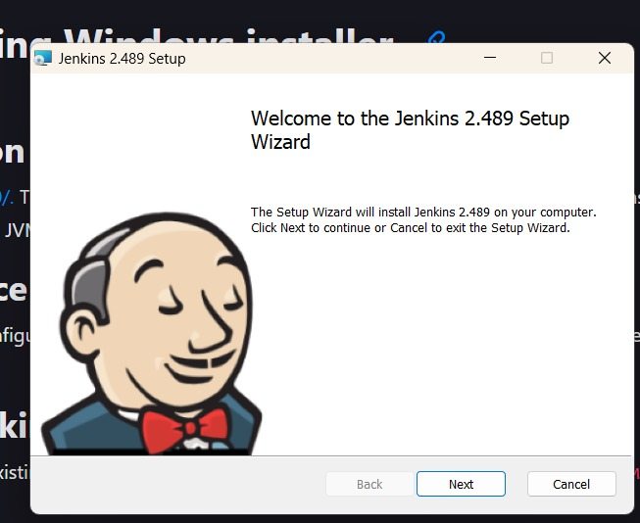

**2.click on Install button**

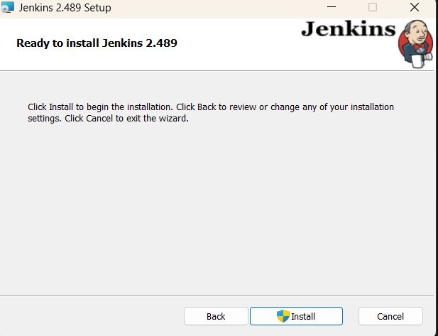

**3.Click on next button**

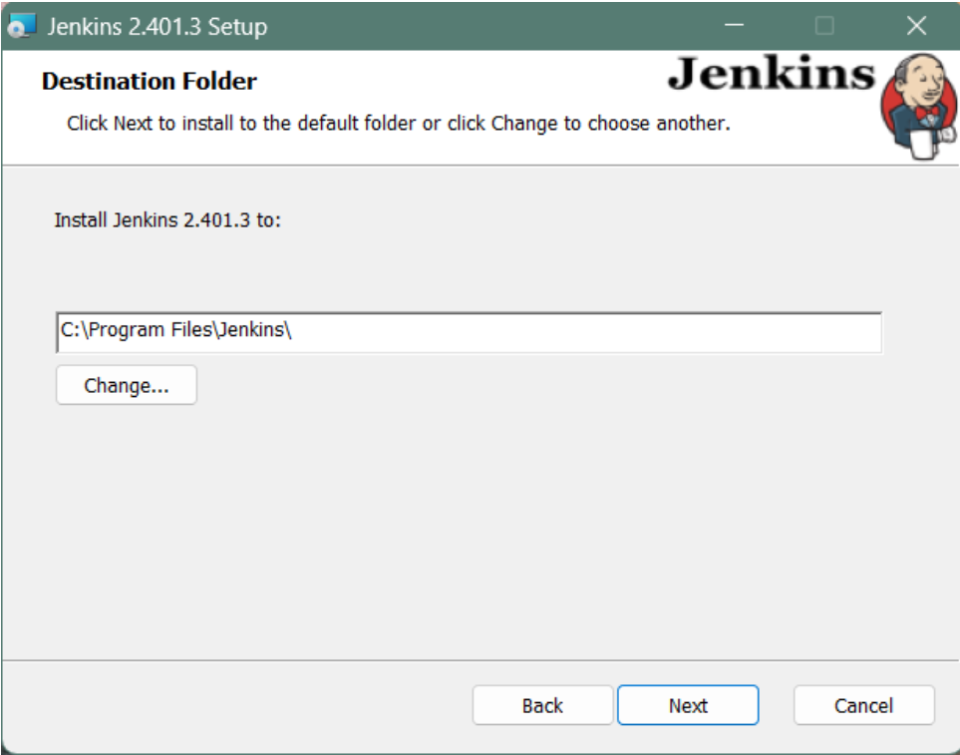

**4. Select Runservice as Localsystem.**

**Give (any)username and password.**

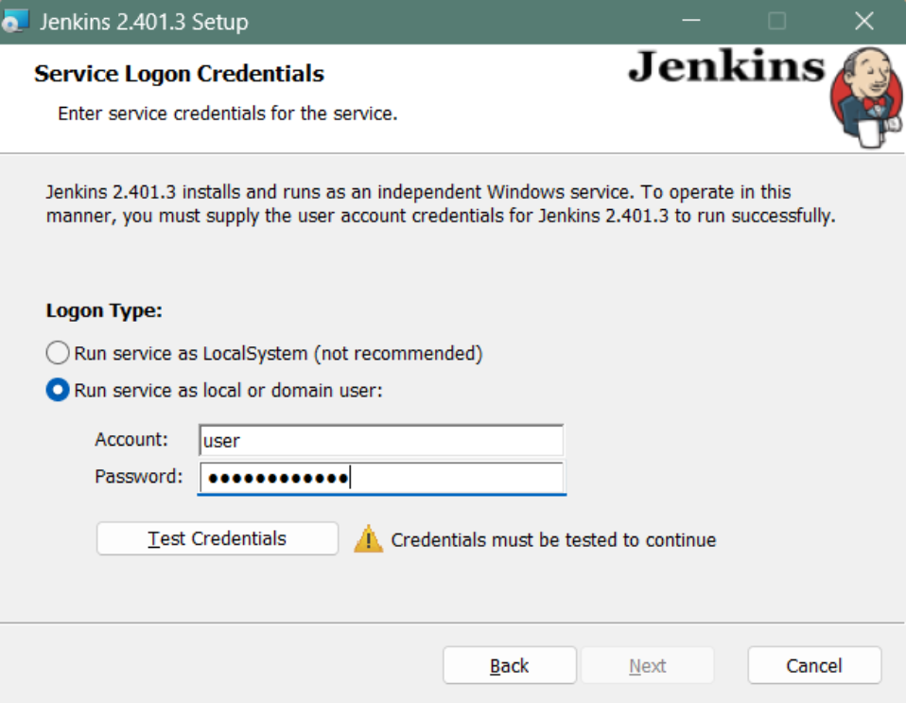

**5.Enter port number 9090 and click on test port and Click on next button.** 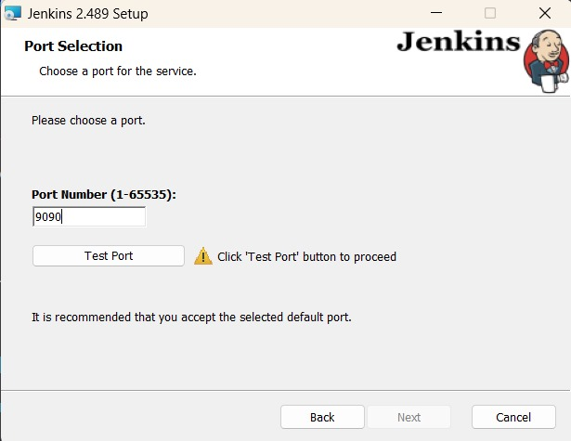

**6.Install jdk latest version jdk**

**Copy path of jdk and paste it “C:\Program Files\Java\jdk-21” and Click next.**

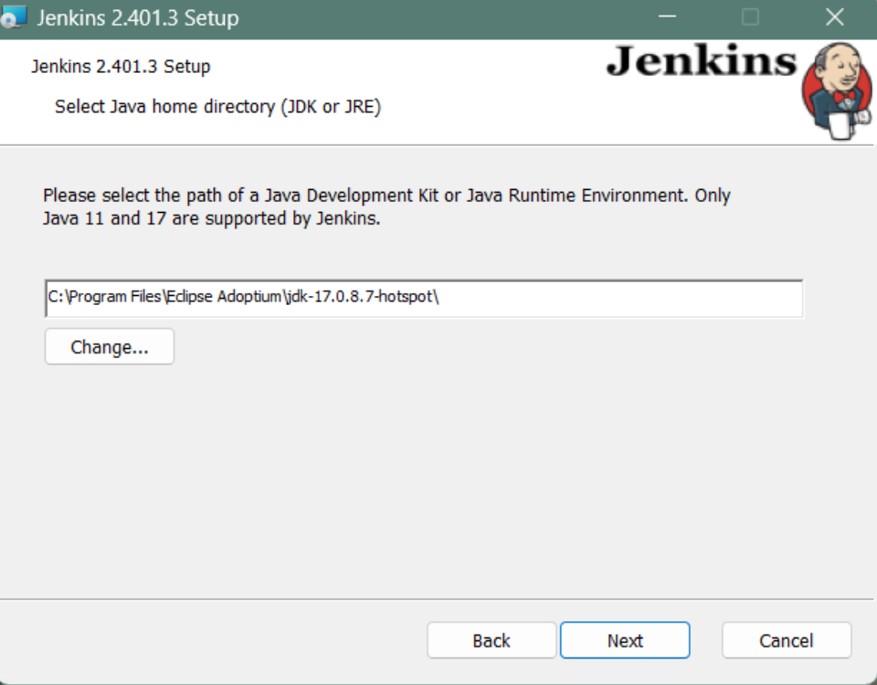

**7.Click on next.**

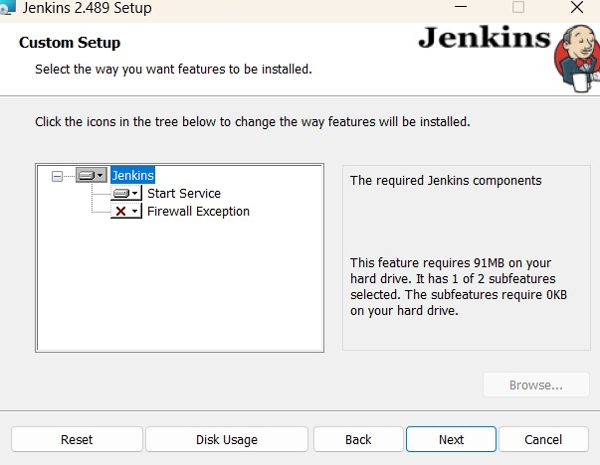

**8.click on Next**

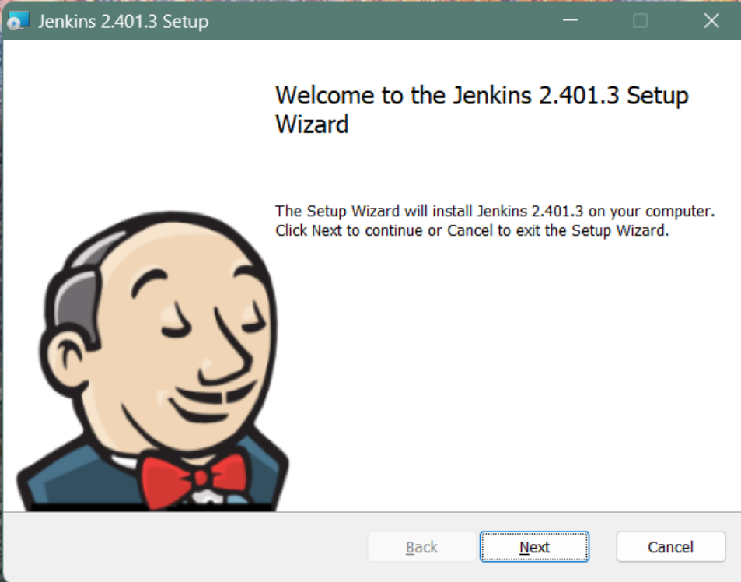

**9.Click on Next**

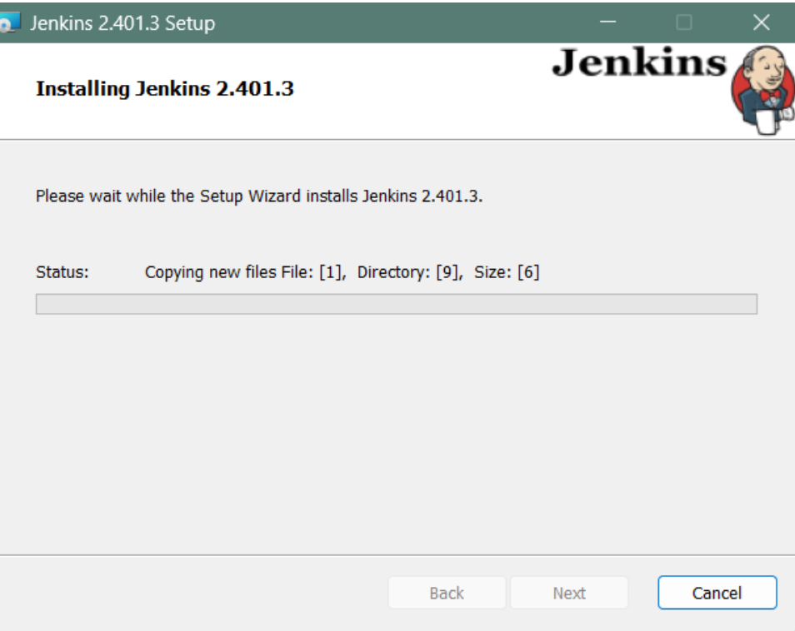

**10.Click on Finish**

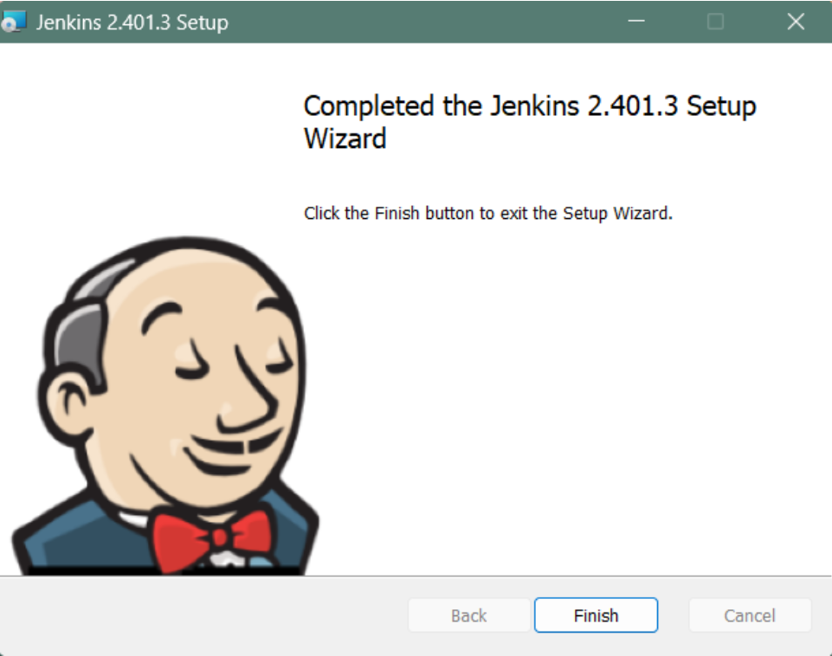

**11.Go to webbrowser and search “localhost:9090”**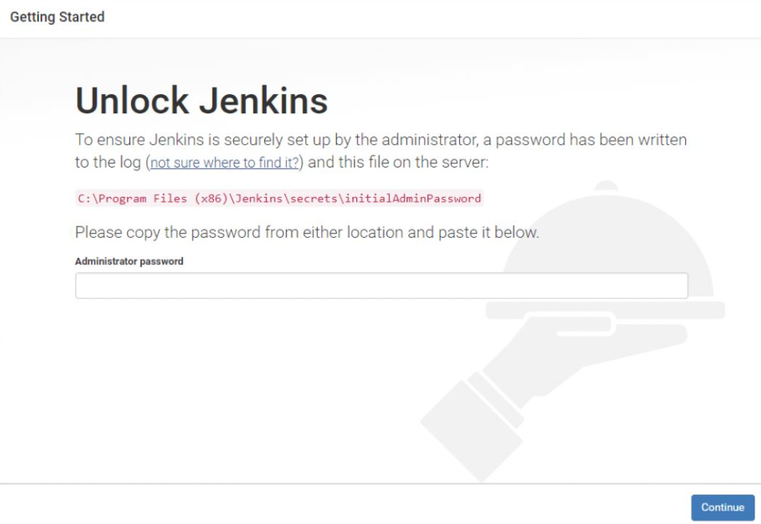

**Go to file explorer go to jdk path location and paste in below “C:\ProgramData\Jenkins\.jenkins\secrets”**

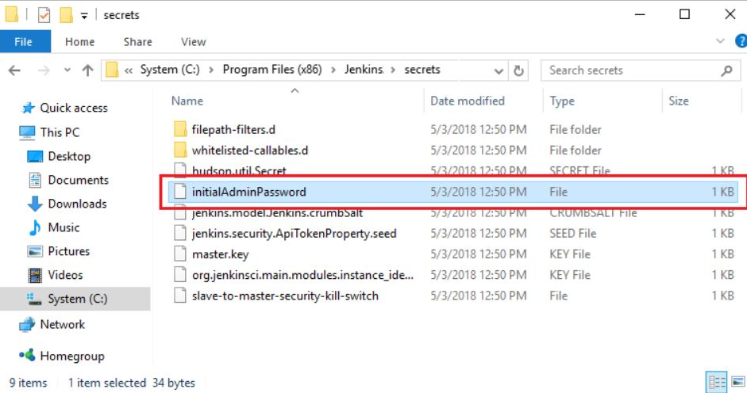



**Open IntialAdminPassword and Copy the text.**

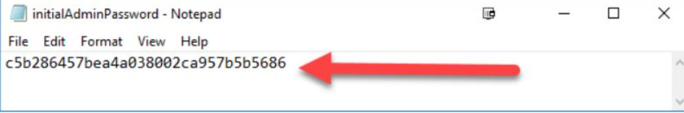

**Paste it in Administration password and Click Continue**

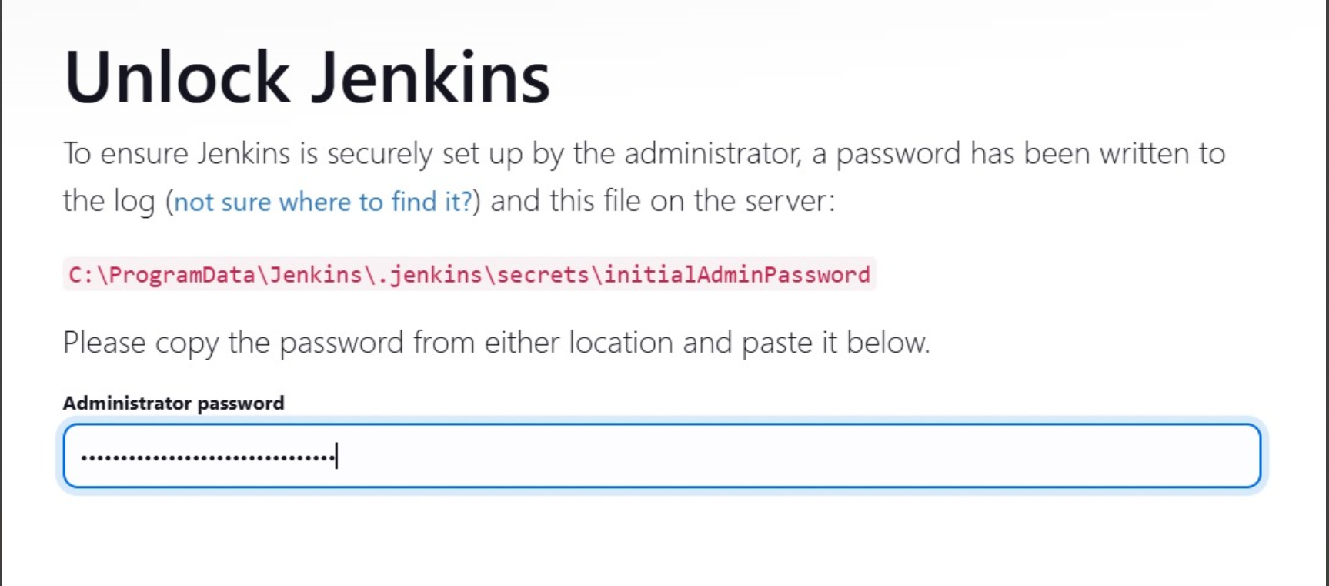

**12.Click on install suggested plans**

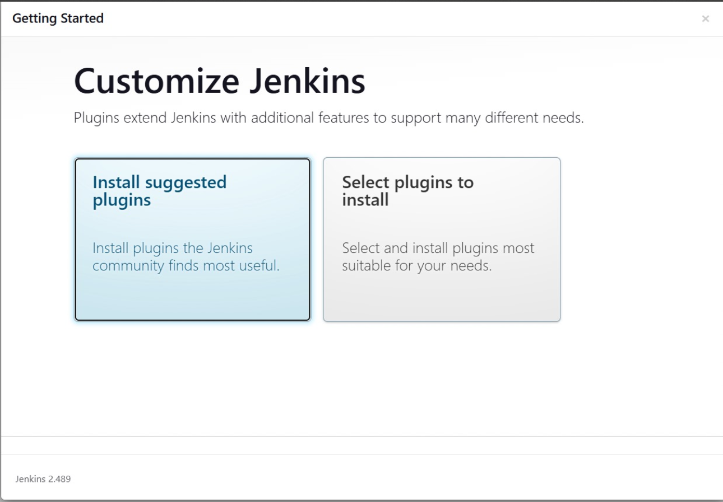

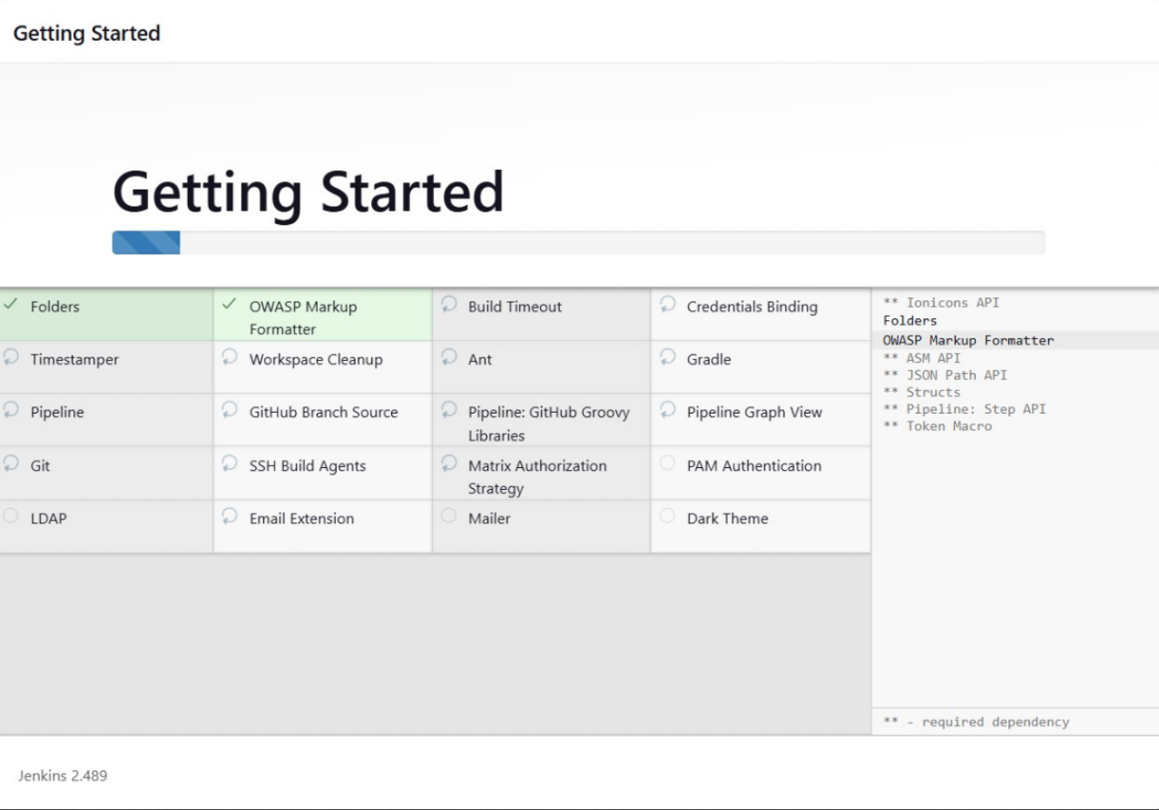

**13.Enter username,password and Emailaddress**

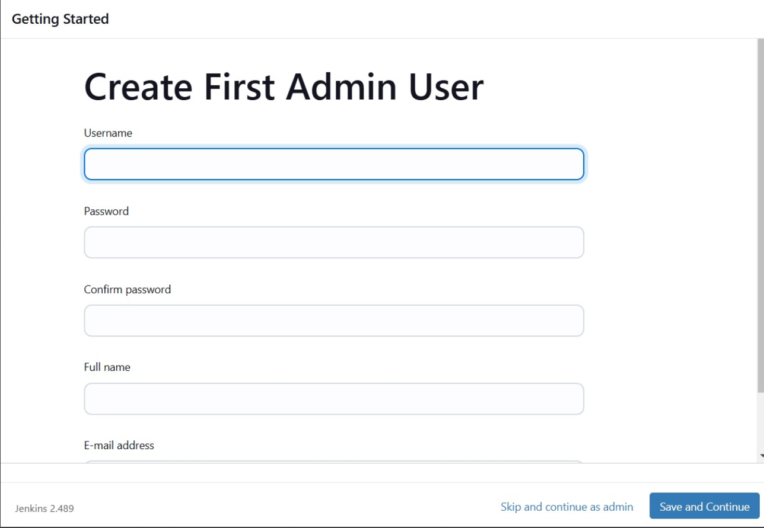

**14.Enter “https://localhost:9090/ and click save and finish**

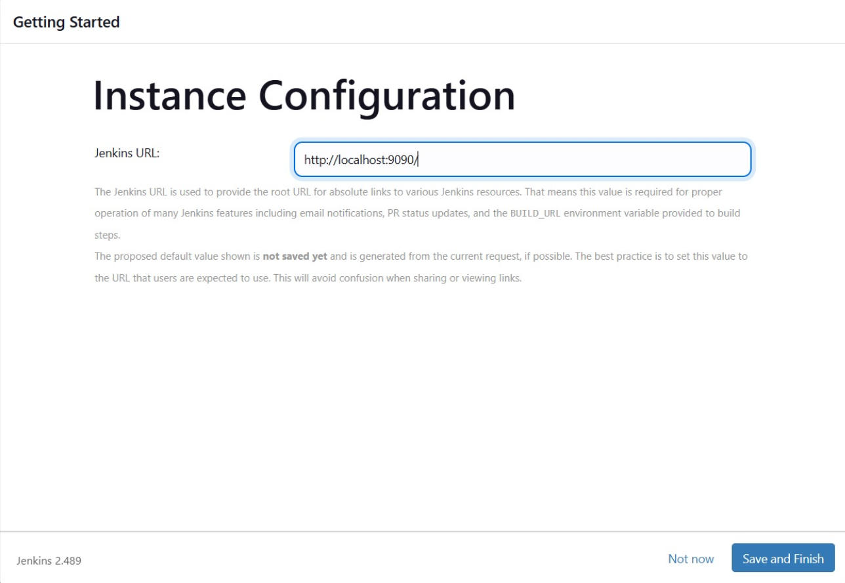

**15. Click on start using jenkins.**

